**LOVELY PROFESSIONAL UNIVERSITY**

**LEARNING SYSTEM**

**INTERNET PROGRAMMING LANGUAGE**

**CSE326**

**SUBMITTED BY:**

**Lomte Vaibhav Baliram (K19AZ,29)**

**Gautam Verma (K19AZ,30)**

**Shubham Patel (K19AZ,31)**

**Kunal Kumar (K19AZ,32)**

Background and Motivation

Firstly, the group would like to thank respected teacher Ishatpreet Kaur for providing such an apex level project. Not only we were able to showcase our coding skills, but also learn the quality teamwork and work division. Moreover, such a project helped us in exploring the various HTML tags and their uses in open world rather than just making the same programs over and over again.

This project fits right in, as if it was chosen by us. That is mainly so because right from the younger classes, there was always an interest to explore the topic as much as possible, rather than just reading the textbook provided by the school. It always felt like we were being spoon-fed. Any topic, especially of science attracted a keen interest because how vast it felt. There is always some history, present and future linked to it. But we were unable to get that interest fulfilled mainly due to the fact that there was no such place for us where we could access all the things related to a topic. Everything was so complex. It was so that a person had to spend hours in looking for the concept. Henceforth, the desire to design a website where we could access all the information at one place began.

Concrete Goals and Objectives

This project is mainly aimed at bridging the gap between different field/steam of studies by bringing a joint place for all of them. So that different students don’t have to look around different websites for their required study material. This way, everything can be found in one place.

Also, within a single field; students can choose the academic level using the ‘Academic Level’ page to get the desired level of knowledge. Not only this, there is also a ‘Feedback’ page where students can leave a feedback if they have any requirement, or there is any bug in the website, or if there is any missing feature they would like to see.

Not only this website provides notes, it also aims at doubt clearing by the assistance of contacting expert teachers which are always there to help them. This website aims to make the student competition level ready by providing sample papers and previous year papers of the top-level entrance exams. There are also many practice questions with gradually increasing level of difficulty so that the student doesn’t feel out of touch of the concept and has a sure grasp over it.

There is something for all kinds of students, belonging to different fields, having different aims, but all for the same goal; to achieve something.

In general, hence the website aims at providing everything for everyone: i.e. for a beginner, there are basics, and for those who want to test their skills, we have high level questions available.

Description of the project:

Here for the designing of the webpage/website, we used the latest version of HTML (Hyper Text Markup Language), CSS (Cascading Style Sheet) and JAVASCRIPT.

We provided all the infrastructure and basic design by using HTML language and style the webpage by using CSS and JAVASCRIPT. We also created certain dialog in between the page while submitting any form type data.

We created 9 HTML web pages, 6 CSS files and 4 JAVA files.

List of HTMLs used in making of project

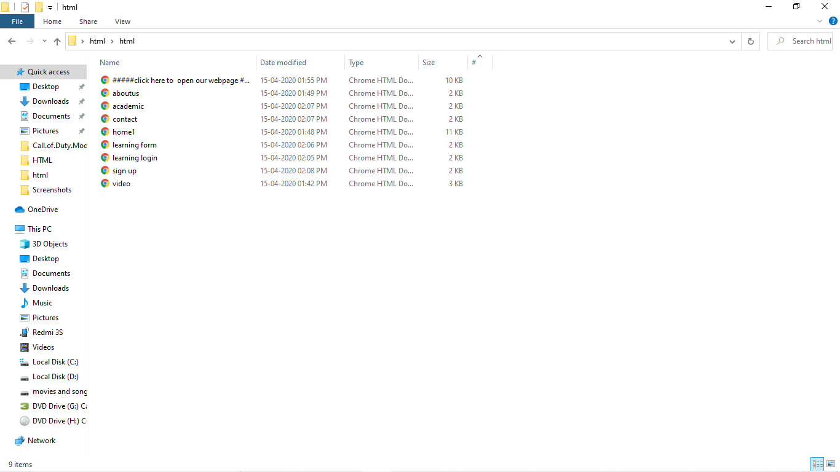

List of CSS used in making of project

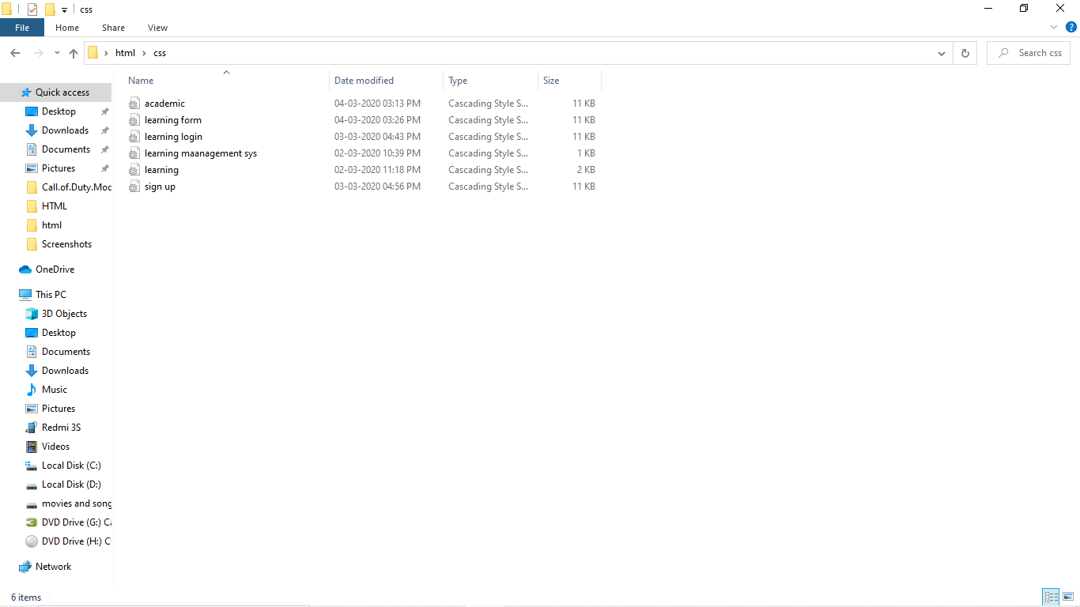

List of JAVASCRIPT used in masking of project

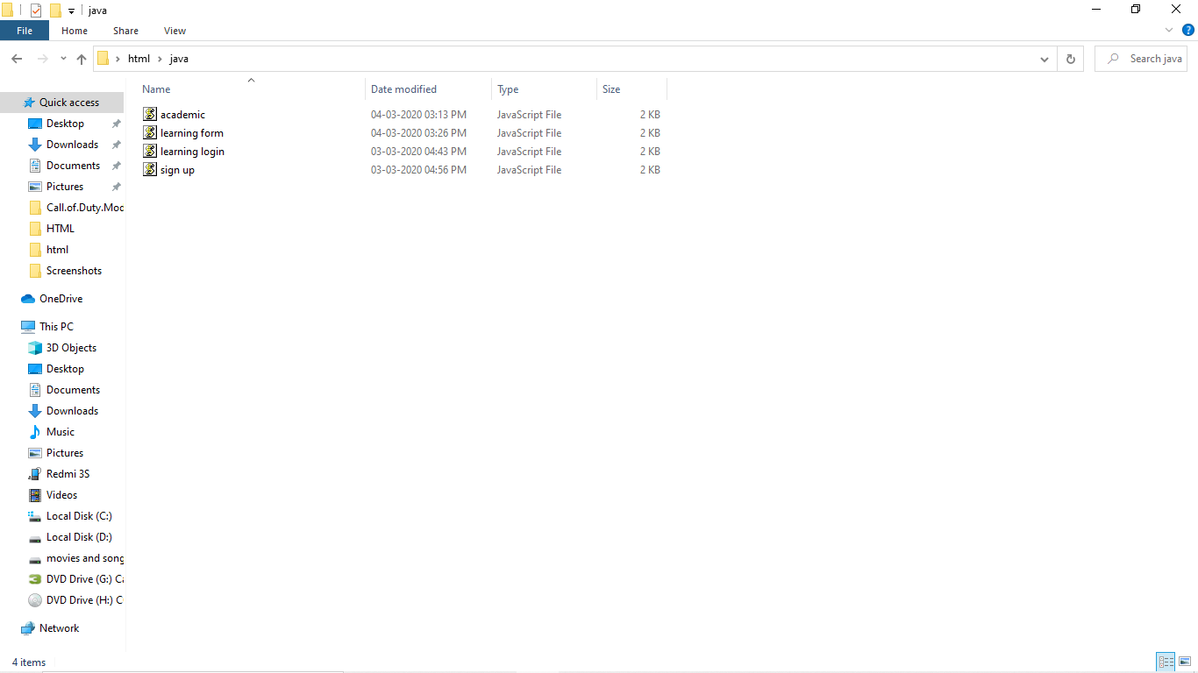

To make our webpage better we used links of some external verified sites like links of: CBSE, JEE Advance, NDA etc.

We also include all parameters in our webpage which were required for any website.

**GANT CHART AND PICTORIAL REPRESENTATION**

The division of the project into smaller parts/modules can be better explained by the Gantt chart below:

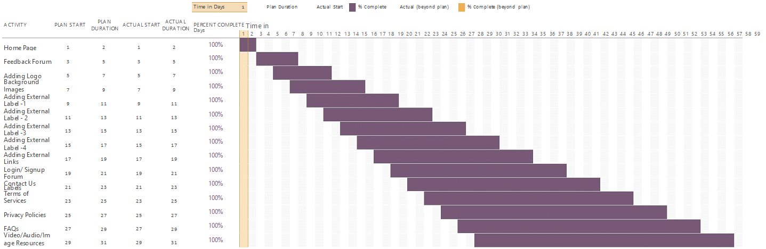

According to the chart, it can be seen that the project has been divided into a number of sections.

Firstly the Home page, through which every other page can be accessed within and interacted.

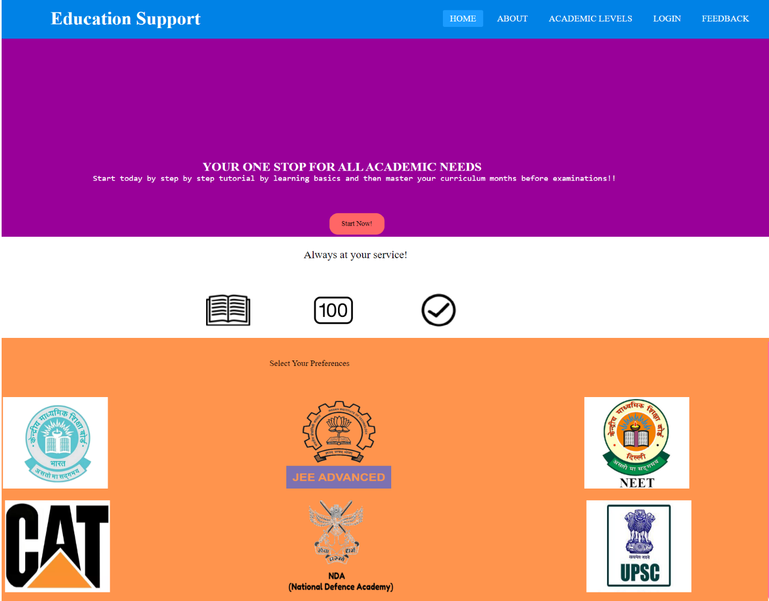

*The main page through which all parts of the website can be accessed.*

Then after the completion of the external tabs, there is an interactive Academic Level page and a Feedback form too.

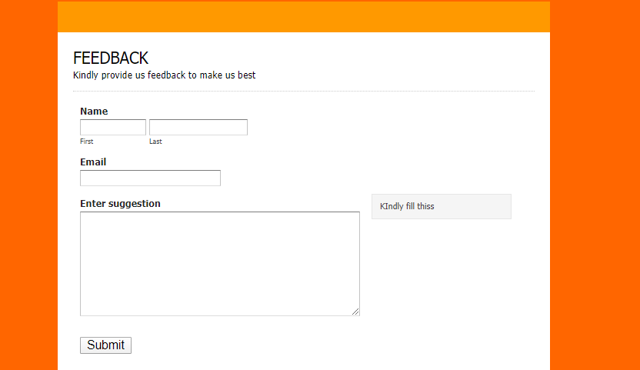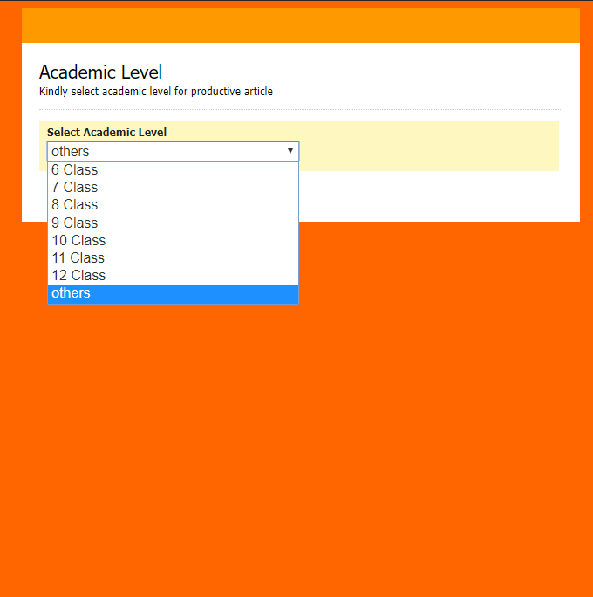

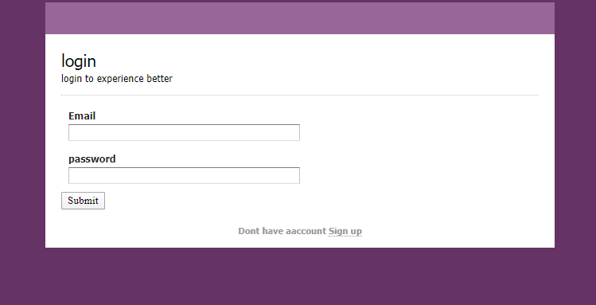

*The Academic Level, Feedback and Login Pages*

Then after the completion of the external tabs, there is special button names START NOW which contain our special feature “Video Lecture” and Fancy Scroll Bar..

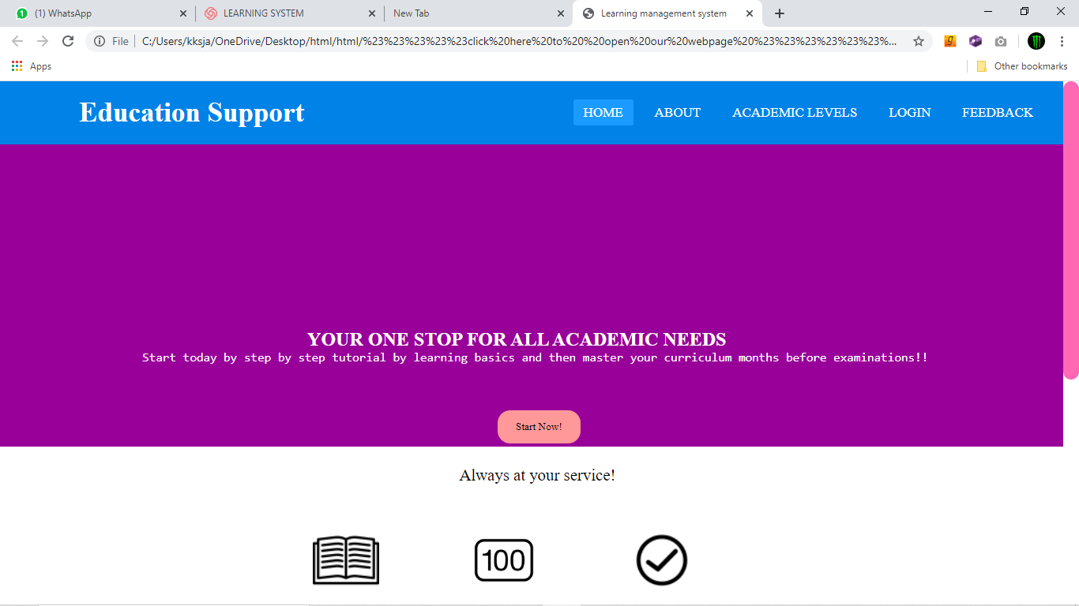 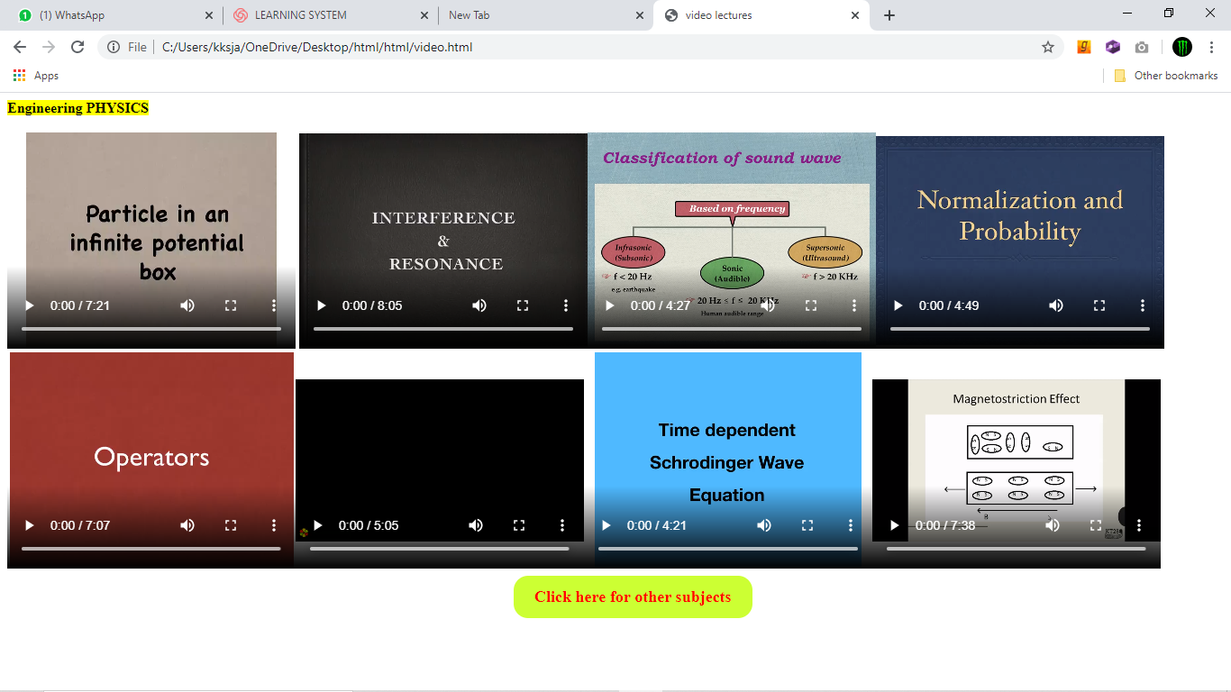

*The start now page and list of videos in it.*

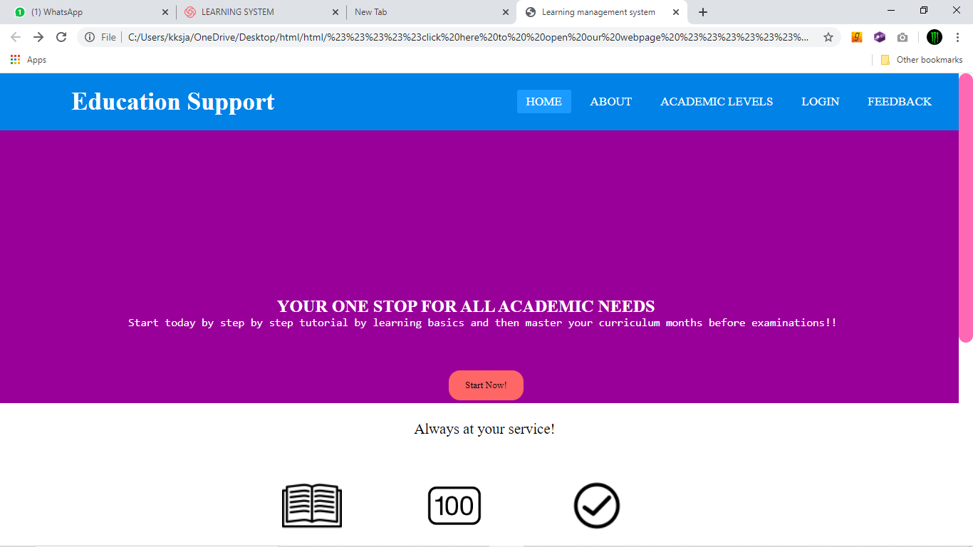 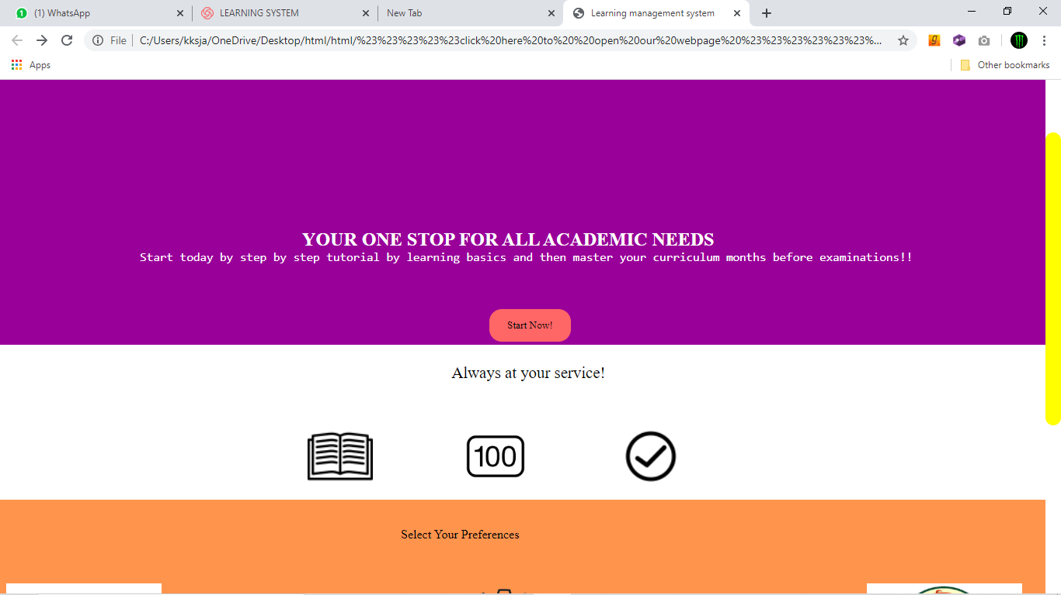

*The Scroll bar before and after touch respectively*

Division of work

The work was divided between the group as follows:

Vaibhav Lomte (Roll No. 29) was given the task of arranging the images, links and other useful resources required in making of the project.

Gautam Verma (Roll No. 30) completed the task of designing the Home page, About Us page and a major portion of the project synopsis and final project report.

Shubham Patel (Roll No. 31) was given the task of designing and making of Login and Signup pages.

Kunal Kumar (Roll No. 32) completed the task of designing the Feedback page, Academic level page, the required External CSS use and making of the explanation video of the project.

Technologies & Framework

The making of this project includes the following software:

Notepad:

Used for making of the HTML based website.

Sublime Text 3:

Used for making of the HTML based website and other pages.

Microsoft Word 2019:

Used in making project synopsis and final report.

Microsoft Excel 2019:

Used for deciding the work flow using Gantt chart.

Google Chrome:

Used for exploring desired tags and gathering required

knowledge.

LOOM:

Making the project explanation video.